Drafting a Model Based on Use Case

David Graves
Colorado State University Global
CSC505
Dr. Steven Evans
February 11, 2025

The Case for Using a Use Case
Developing a use case for a proposed product is extremely helpful for engineers in understanding many different facets for the product they are meant to build. Answering questions like who the user is, what are their goals, what information do they want from the system and other questions are critical to designing a useful product. Having the end users assist in answering those questions directly is considered good practice and, “one of the best ways to do this is to have each stakeholder write use cases that describe how the software will be used”. (Pressman & Maxim, n.d., Pg 119) These use cases can be compiled to understand the overall expected flow of interaction with the product, and it’s expected outcome. This work can also start to shed light on possible core requirements that the project team can start to consolidate and outline. One additional key benefit to collecting uses cases up front is that “real system needs can be identified earlier in the design process”. (Brush, 2022, Paragraph 9) As discussed there are many benefits to building a use case prior to starting software development during a project. I’ll use the remainder of this paper to share both a UML diagram, and associated Python script for a possible use case for a web-based pothole tracking and repair system showing the interactions of two different actors with the proposed online system.
Modeling in Action
In lieu of actual user and stakeholder feedback I’ve imagined a scenario making several assumptions about how the actors in the following use case interact with the pothole tracking and repair system. Prior to writing a prototype in Python to show this use case, it would be useful to have a map of how the users plan on interacting with the system. I used a Unified Model Language chart to build the proposed use case including the actors and the system they would be interacting with below in Image 1.
Image 1 (1 of 2) - UML ‘PHTRS Use Script’
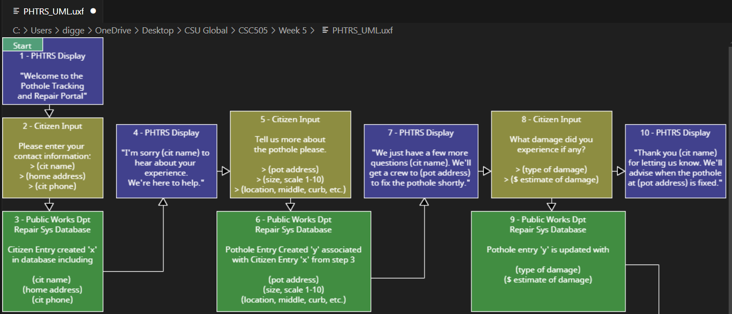
Image 1 (2 of 2) - UML ‘PHTRS Use Script’
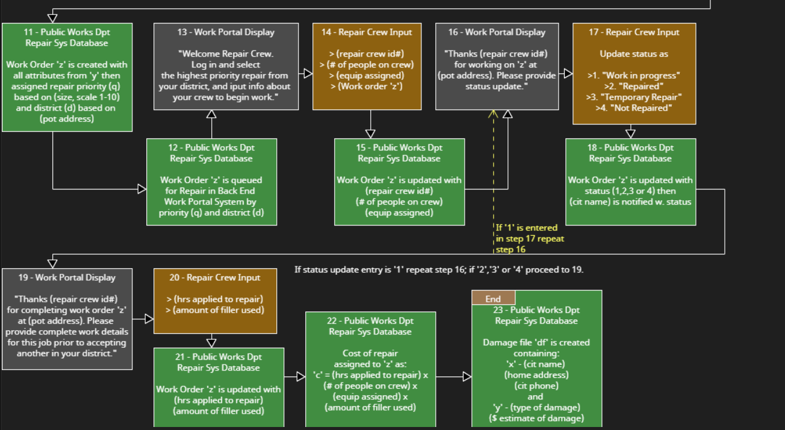
The Python code for the use case diagram with multiple actors and systems, and their interactions with those systems is shown in the following Image 2.
Image 2 (1 of 3) - Python Program ‘PHTRS Actor & Use Script’
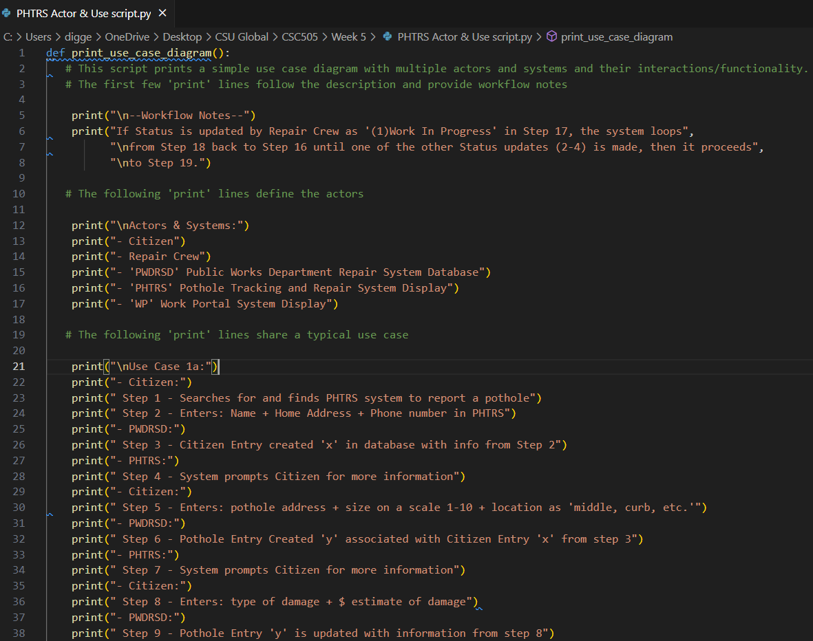

Image 2 (2 of 3) - Python Program ‘PHTRS Actor & Use Script’
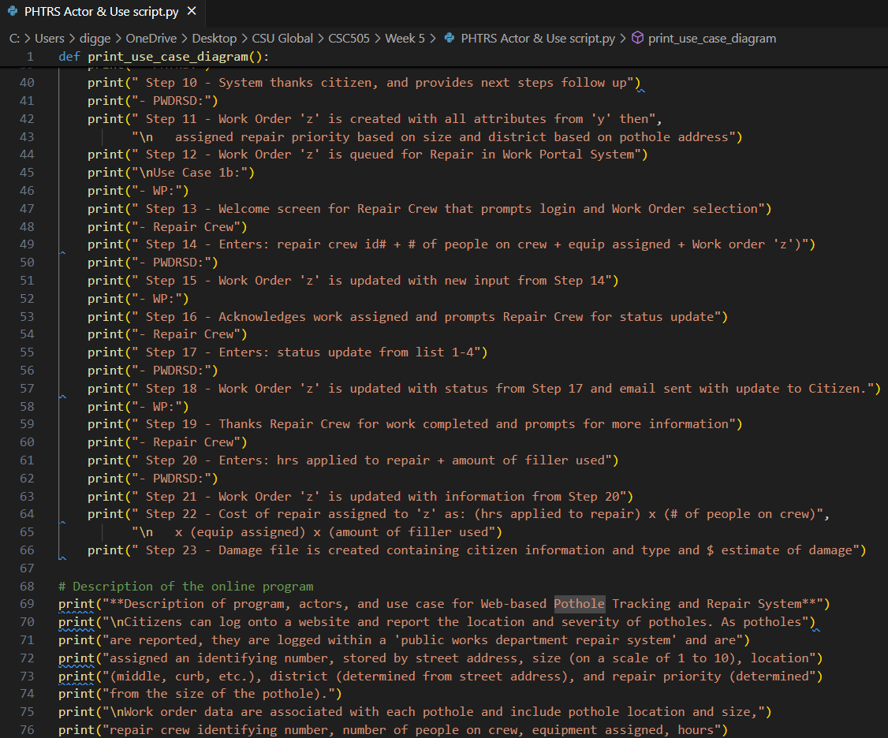
Image 2 (3 of 3) - Python Program ‘PHTRS Actor & Use Script’
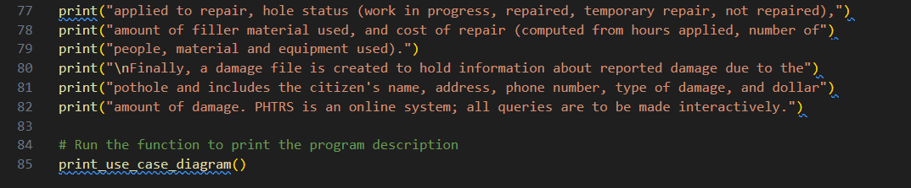

The following Image 3 shows the Terminal output for the page use case script and clearly prints the program description, workflow notes, actors, systems, and the use case.
Image 3 (1 of 3) - Terminal Output ‘PHTRS Actor & Use Script’
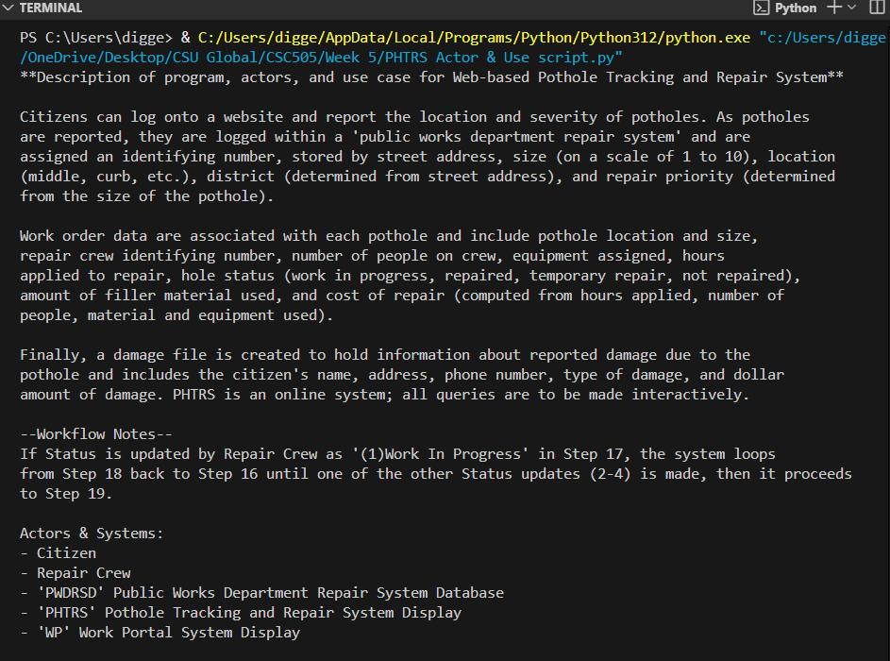

Image 3 (2 of 3) - Terminal Output ‘PHTRS Actor & Use Script’
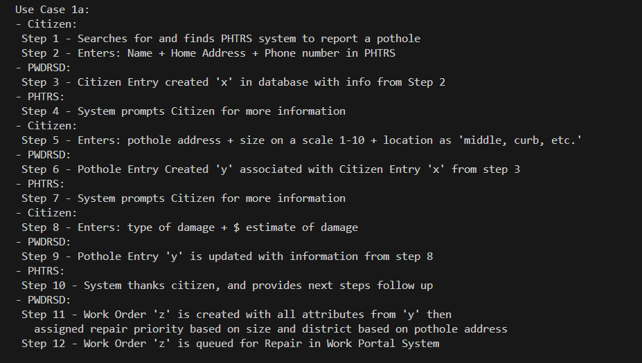
Image 3 (3 of 3) - Terminal Output ‘PHTRS Actor & Use Script’
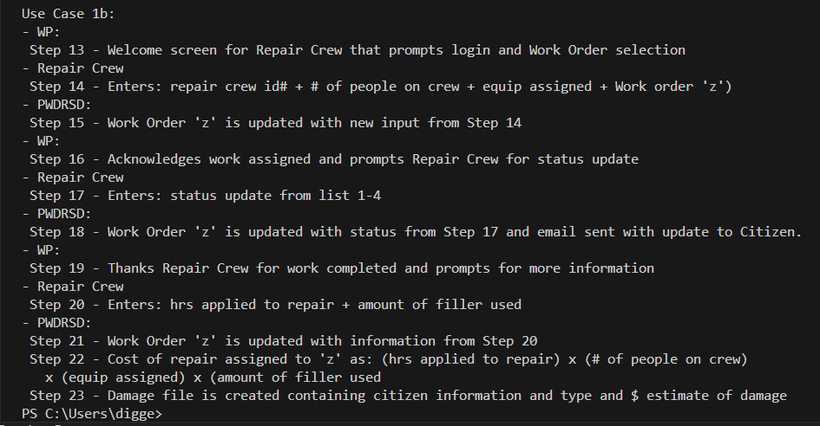

Reflection
This exercise was the most challenging to date and forced me to think about how and where to store information as multiple actors changed and manipulated it while the scenario played out. With more straightforward exercises in previous weeks, I found that drafting the code while building the UML worked well, however this week I intentionally started building the UML prior to drafting any code and found it rewarding. With multiple actors and different requirements for an online tracking system adding complexity to the overall design it’s clear how helpful a use-case map that can be shared with stakeholders and other fellow developers can help everyone stay on the same page. In Jessica Powers words from her recent article, “even developers sometimes find themselves in long technical conversations, only to realize that they weren’t really describing the same thing at all”. (Powers, 2022, Paragraph 2) Both Jessica and I find common ground in the belief that a good UML can be a useful tool, making the time spent drafting one based off use-case scenarios a solid investment paying dividends in ensuring that the project team builds a product that end users will find useful.

References
Brush, Kate (2022, November). Techtarget.com. Use Case.
https://www.techtarget.com/searchsoftwarequality/definition/use-case
Powers, Jessica (2022, September 8). Builtin.com. Learning UML Diagrams Will Make You a
Better Developer. https://builtin.com/software-engineering-perspectives/uml-diagrams
Pressman, R. S., & Maxim, B. R. (n.d.). Software Engineering: A Practitioner’s Approach.
Retrieved from https://platform.virdocs.com/read/1490446/152/#/4/4

